***web engineering lab # 5***

***TASK # 1:***

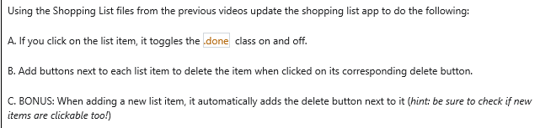

***CODE:*** <!DOCTYPE html>

<html>

<head>

<meta name="viewport" content="width=device-width, initial-scale=1">

<style>

body {

  margin: 0;

  min-width: 250px;

}

* {

  box-sizing: border-box;

}

ul {

  margin: 0;

  padding: 0;

}

ul li {

  cursor: pointer;

  position: relative;

  padding: 12px 8px 12px 40px;

  list-style-type: none;

  background: #eee;

  font-size: 18px;

  transition: 0.2s;

  -webkit-user-select: none;

  -moz-user-select: none;

  -ms-user-select: none;

  user-select: none;

}

ul li:nth-child(odd) {

  background: #f9f9f9;

}

ul li:hover {

  background: #ddd;

}

ul li.checked {

  background: #888;

  color: #fff;

  text-decoration: line-through;

}

ul li.checked::before {

  content: '';

  position: absolute;

  border-color: #fff;

  border-style: solid;

  border-width: 0 2px 2px 0;

  top: 10px;

  left: 16px;

  transform: rotate(45deg);

  height: 15px;

  width: 7px;

}

.close {

  position: absolute;

  right: 0;

  top: 0;

  padding: 12px 16px 12px 16px;

}

.close:hover {

  background-color: #f44336;

  color: white;

}

.header {

  background-color: #f44336;

  padding: 30px 40px;

  color: white;

  text-align: center;

}

.header:after {

  content: "";

  display: table;

  clear: both;

}

input {

  margin: 0;

  border: none;

  border-radius: 0;

  width: 75%;

  padding: 10px;

  float: left;

  font-size: 16px;

}

.addBtn {

  padding: 10px;

  width: 25%;

  background: #d9d9d9;

  color: #555;

  float: left;

  text-align: center;

  font-size: 16px;

  cursor: pointer;

  transition: 0.3s;

  border-radius: 0;

}

.addBtn:hover {

  background-color: #bbb;

}

</style>

</head>

<body>

<div id="myDIV" class="header">

  <h2 style="margin:5px">My To Do List</h2>

  <input type="text" id="myInput" placeholder="Title...">

  <span onclick="newElement()" class="addBtn">Add</span>

</div>

<ul id="myUL">

  <li>Hit the gym</li>

  <li class="checked">Pay bills</li>

  <li>Meet George</li>

  <li>Buy eggs</li>

  <li>Read a book</li>

  <li>Organize office</li>

</ul>

<script>

var myNodelist = document.getElementsByTagName("LI");

var i;

for (i = 0; i < myNodelist.length; i++) {

  var span = document.createElement("SPAN");

  var txt = document.createTextNode("\u00D7");

  span.className = "close";

  span.appendChild(txt);

  myNodelist[i].appendChild(span);

}

var close = document.getElementsByClassName("close");

var i;

for (i = 0; i < close.length; i++) {

  close[i].onclick = function() {

    var div = this.parentElement;

    div.style.display = "none";

  }

}

var list = document.querySelector('ul');

list.addEventListener('click', function(ev) {

  if (ev.target.tagName === 'LI') {

    ev.target.classList.toggle('checked');

  }

}, false);

function newElement() {

  var li = document.createElement("li");

  var inputValue = document.getElementById("myInput").value;

  var t = document.createTextNode(inputValue);

  li.appendChild(t);

  if (inputValue === '') {

    alert("You must write something!");

  } else {

    document.getElementById("myUL").appendChild(li);

  }

  document.getElementById("myInput").value = "";

  var span = document.createElement("SPAN");

  var txt = document.createTextNode("\u00D7");

  span.className = "close";

  span.appendChild(txt);

  li.appendChild(span);

  for (i = 0; i < close.length; i++) {

    close[i].onclick = function() {

      var div = this.parentElement;

      div.style.display = "none";

    }

  }

}

</script>

</body>

</html>

***OUTPUT:***

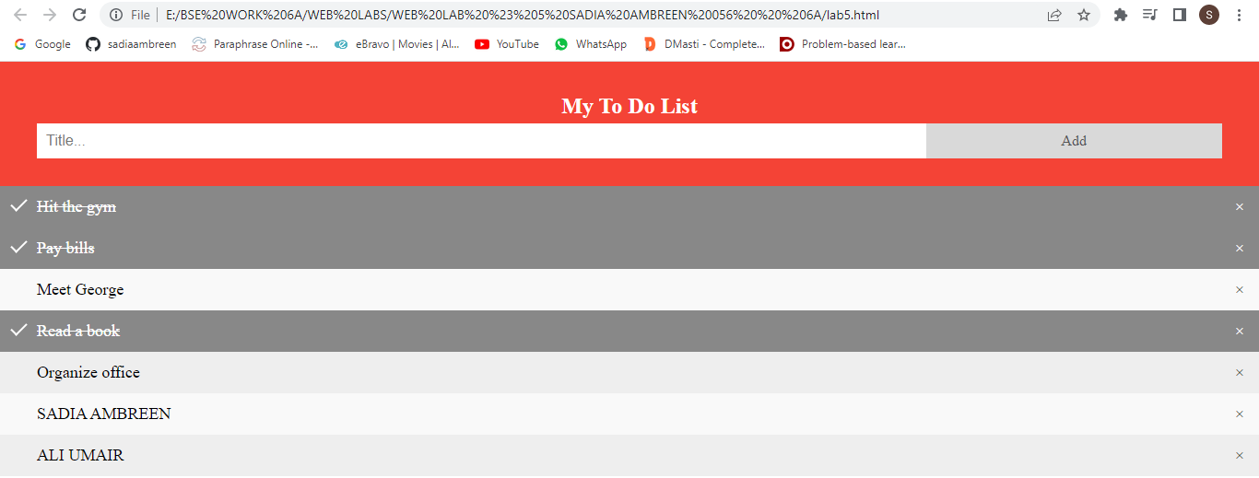

***TASK # 2:***

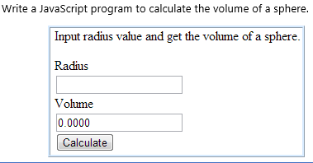

***CODE:*** <!DOCTYPE html>

<html lang="en">

<head>

    <meta charset="UTF-8">

    <meta http-equiv="X-UA-Compatible" content="IE=edge">

    <meta name="viewport" content="width=device-width, initial-scale=1.0">

    <title>Document</title>

</head>

<body>

    <h2 style="text-align: center; color: rgb(0, 0, 0); font-family: 'Times New Roman', Times, serif; font-style: italic;">Input radius value and get the volume of sphere</h2>

    <br>

    <form style="text-align: center;">

        <h3 style="color: rgb(121, 1, 1);">RADIUS</h3>

        <input type = number id="Rad" name="rad">

        <h3 style="color:  rgb(139, 5, 0);">VOLUME</h3>

        <input type = number id="vol" name="vol">

        <br>

        <button type="button" id="btn" style="background-color: rgb(255, 251, 0);">Calculate Volume</button>

    </form>

    <script type="text/javascript">

function calculateVolume()

{

let radius = document.getElementById("Rad").value;

let volume = 4/3*Math.PI*Math.pow(radius,3);

document.getElementById("vol").value = volume.toFixed(2);

}

let button = document.getElementById("btn");

button.onclick = calculateVolume;

    </script>

</body>

</html>

***OUTPUT:*** 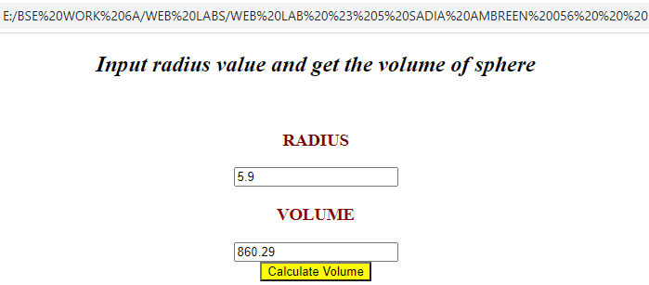

***TASK # 3:***

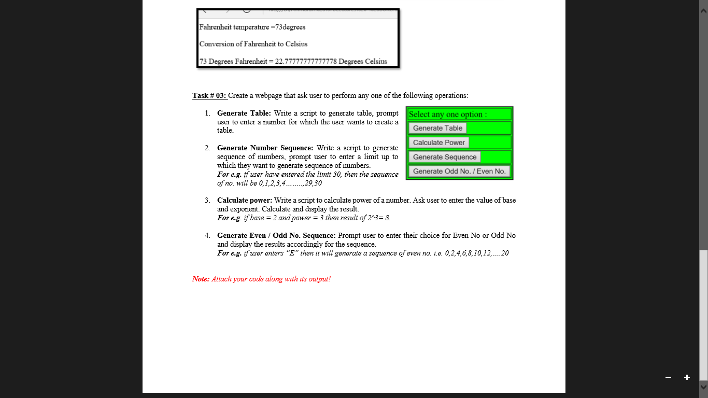

***CODE:*** <!DOCTYPE html>

<html lang="en">

<head>

        <meta charset="utf-8">

        <meta name="viewport" content="width=device-width, initial-scale=1">

        <link href="https://cdn.jsdelivr.net/npm/bootstrap@5.1.3/dist/css/bootstrap.min.css" rel="stylesheet" integrity="sha384-1BmE4kWBq78iYhFldvKuhfTAU6auU8tT94WrHftjDbrCEXSU1oBoqyl2QvZ6jIW3" crossorigin="anonymous">

        <link href="../assets/dist/css/bootstrap.min.css" rel="stylesheet">

</head>

<body>

    <br>

    <h2 class="text-center">TASK # 3 </h2>

  <div class="container" style="background-color: rgb(105, 0, 0); ">

      <div class="row">

        <div class="col-12">

          <table class="table table-bordered">

            <thead>

              <tr>

                <th scope="col" style="color:white">SELECT ANY ONE OPTION:</th>

              </tr>

            </thead>

            <tbody>

              <tr>

                <td scope="row"><button type="button" onclick="generateTable()" class="btn btn-outline-light">Generate table</button></td>

              </tr>

              <tr>

                  <td scope="row"><button type="button" onclick="calculatePower()" class="btn btn-outline-light">Calculate Power</button></td>

                </tr>

                <tr>

                  <td scope="row"><button type="button" onclick="generateSeries()" class="btn btn-outline-light">Generate Series</button></td>

                </tr>

                <tr>

                  <td scope="row"><button type="button" onclick="generateEvenOdd()" class="btn btn-outline-light">Generate odd No./Even No.</button></td>

                </tr>

            </tbody>

          </table>

        </div>

      </div>

    </div>

    <br>

</body>

<script type="text/javascript">

function generateTable () {

  var number = prompt("Please enter a number:");

  document.write('<table border="1">');

  for (i=1; i <= 12; i++) {

      document.write('<tr><td>' + number + " x " + i + "</td><td>=</td><td>" + i*number + "</td></tr>");

  };

  document.write('</table>');

}

function calculatePower () {

  var base = prompt("Please enter a Base: ");

  var power = prompt("Please enter a Power: ");

  let x = Math.pow(base, power);

  document.write("The result is: "+x);

}

function generateSeries () {

  var start = prompt("Please enter a Start: ");

  var end = prompt("Please enter a End: ");

  for (i=start; i <= end; i++) {

      document.write( i +"," +" " );

  };

}

  function generateEvenOdd () {

  var response=prompt("Enter E for Even series/ O for Odd Series");

  var end = prompt("Please enter a Limit: ");

  if (response=="E") {

for (i=2; i <= end; i=i+2) {

      document.write( i +" ");

  }

} else if (response=="O") {

  for (i=1; i <= end; i=i+2) {

     document.write( i  +" ");

 }

}

//task4

function chBackcolor(color) {

 document.button.style.background = color;

}

window.setTimeout("chBackColor()",10000);

  }

  </script>

<script src="../assets/dist/js/bootstrap.bundle.min.js"></script>

<script src="https://cdn.jsdelivr.net/npm/bootstrap@5.1.3/dist/js/bootstrap.bundle.min.js" integrity="sha384-ka7Sk0Gln4gmtz2MlQnikT1wXgYsOg+OMhuP+IlRH9sENBO0LRn5q+8nbTov4+1p" crossorigin="anonymous"></script>

  <script src="https://ajax.googleapis.com/ajax/libs/jquery/3.5.1/jquery.min.js"></script>

  <script src="https://maxcdn.bootstrapcdn.com/bootstrap/3.4.1/js/bootstrap.min.js"></script>

     </html>

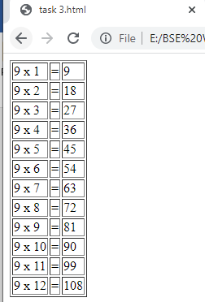</body>

</html>

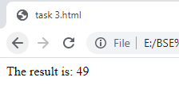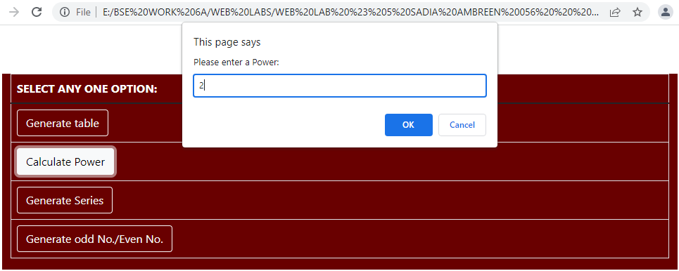***OUTPUT:*** 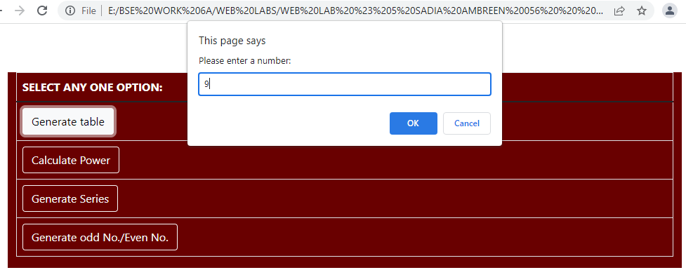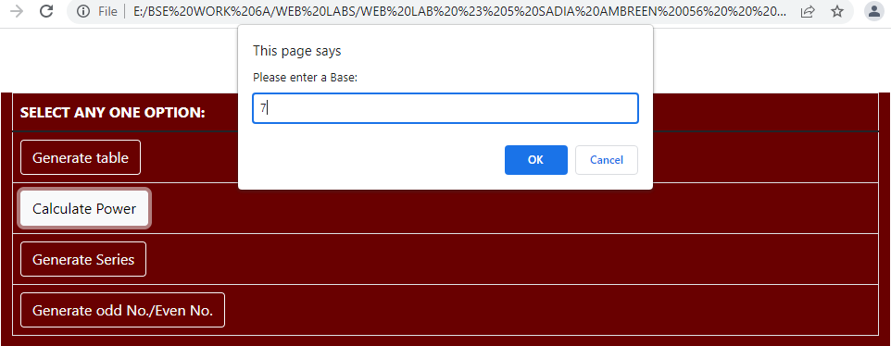

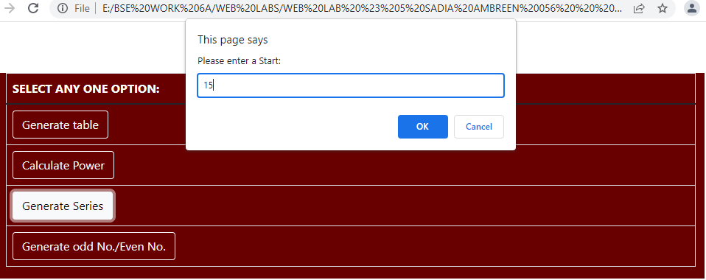

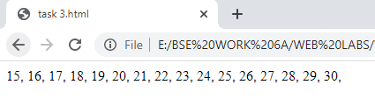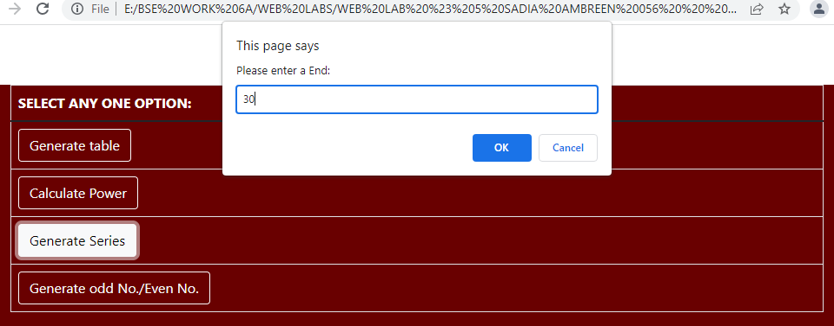

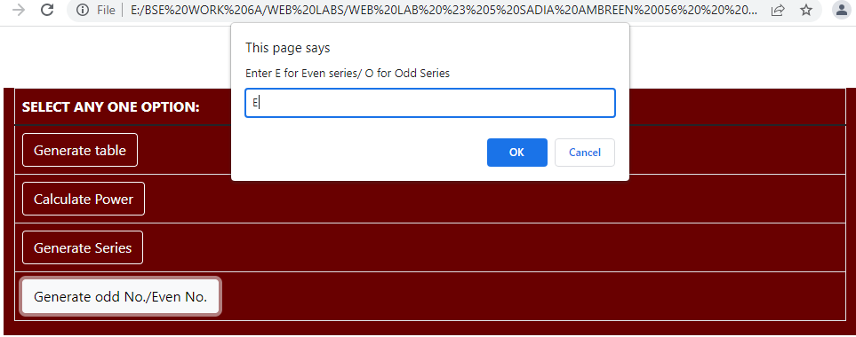

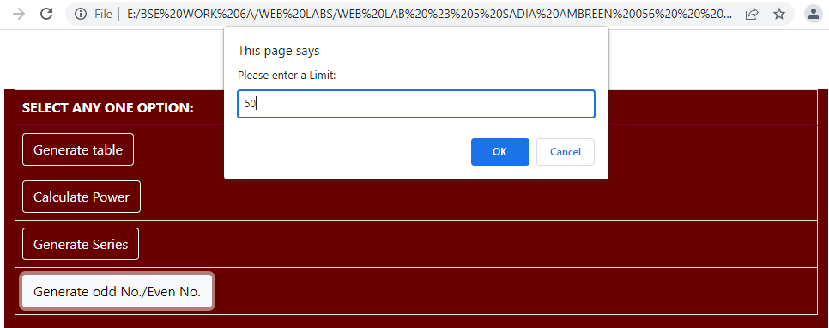

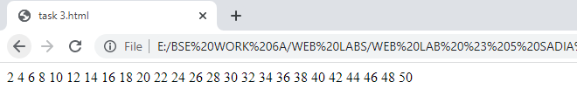

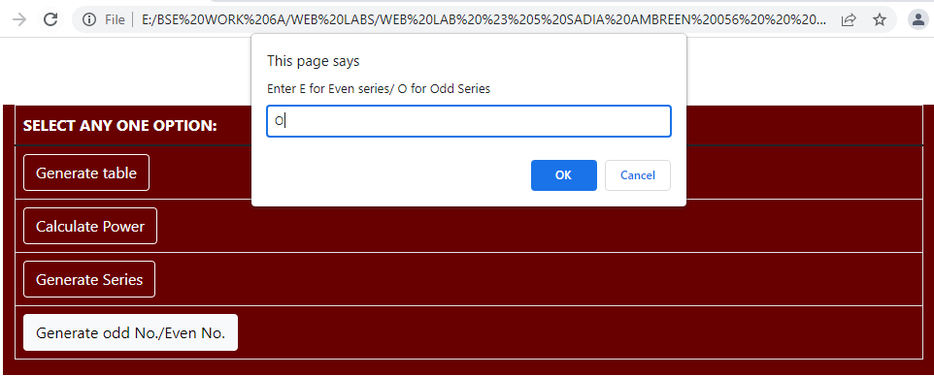

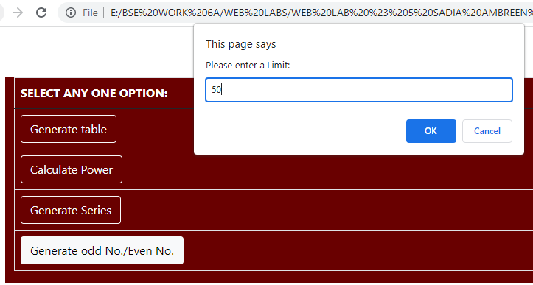

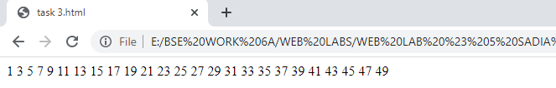S

***TASK # 4:***

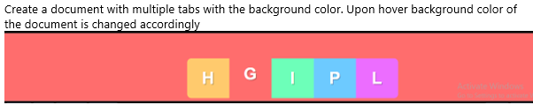

***CODE:*** <!DOCTYPE html>

<html lang="en">

<head>

    <meta charset="UTF-8">

    <meta http-equiv="X-UA-Compatible" content="IE=edge">

<style>

button{

  border: 2px solid black;

  border-radius: 5px;

}

</style>

</head>

<body style=" top:0px; left:0px;background-color: rgba(226, 112, 92, 0.979);">

    <ul class="nav nav-pills"  >

      <button type="button" id="btn1"class="btn btn-lrg" style="height: 50px; width: 50px; margin-left: 30px;">S</button>

      <button type="button" id="btn2"class="btn btn-lrg" style="height: 50px; width: 50px; ">A</button>

      <button type="button" id="btn3" class="btn btn-lrg" style="height: 50px; width: 50px; ">D</button>

      <button type="button" id="btn4" class="btn btn-lrg" style="height: 50px; width: 50px; ">I</button>

      <button type="button" id="btn5"class="btn btn-lrg" style="height: 50px; width: 50px; ">A</button>

    </ul>

</body>

    <script type="text/javascript">

const btn1 = document.getElementById("btn1");

      btn1.addEventListener("mouseover", function () {

        btn1.style.backgroundColor = "orange";

 });

 const btn2 = document.getElementById("btn2");

 btn2.addEventListener("mouseover", function () {

  btn2.style.backgroundColor = "red";

 });

 const btn3 = document.getElementById("btn3");

      btn3.addEventListener("mouseover", function () {

        btn3.style.backgroundColor = "green";

 });

 const btn4 = document.getElementById("btn4");

      btn4.addEventListener("mouseover", function () {

        btn4.style.backgroundColor = "powderblue";

 });

 const btn5 = document.getElementById("btn5");

      btn5.addEventListener("mouseover", function () {

        btn5.style.backgroundColor = "plum";

 });

</script>

</html>

***OUTPUT:***

